



Po Box 200, Harrogate England, United Kingdom
E-mail: bbc2015claimsdesk01@outlook.com
Tele: +447010059303
Visit Our Web Site http://www.bbc.co.uk/programmes/b03xkcgn ,
http://www.bbc.co.uk/programmes/b01r52tw
draws: No. 0021
(08) (12) (13) (14) (18) (38) (43) BONUS (48) (37) DRAWS NO. 641

Dear Lucky Winner,

This is to inform you that you have won a prize MONEY of £500,000.00 Great British Pounds, and a new BMW 5 SERIS CAR of the Yearly BBC Lottery promotion United Kingdom which is organized by BBC in conjunction with Chevron Texaco Oil and Gas Company. “Your Email Address" was selected through a computer ballot system drawn from Nine hundred thousand emails, from Canada, Australia, United States, Asia, Europe, Middle East, Africa and Oceanic as part of our international promotions program which is conducted annually, we have only selected 20 people as our winners, and two Indians were selected which you are among the two.

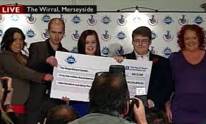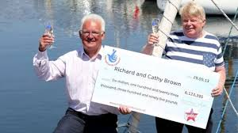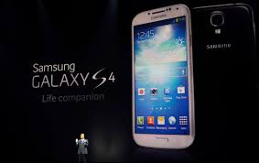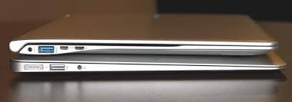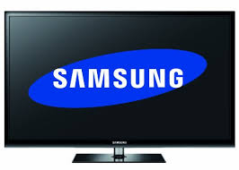
APPROVED PAYMENT OFFICER
DR.TERRY COLE
Help Line: +447010059303
MAKE SURE YOU SEND YOUR DETAILS TO THIS EMAIL} bbc2015claimsdesk01@outlook.com TO ENABLE US RESPOND TO YOU ON TIME

1. Name
2. AGE
3. Sex
4. Mobile No
5. Address
6. Country/State
7. Occupation
8. Language Known
9. Email
10. Your Full Name(s)
11. Your Bank Name
12. Account Number:
13. Bank Address

PLEASE: YOU ARE TO FORWARD YOUR COMPLETE DETAILS INCLUDING BANK DETAILS TO US FOR EASY TRANSFER OF YOUR WINNING PRIZE AND ALSO
YOUR (4X4) PASSPORT PHOTOGRAPH.
MAKE SURE YOU SEND YOUR DETAILS TO THIS EMAIL} bbc2015claimsdesk01@outlook.com TO ENABLE US RESPOND TO YOU ON TIME

MR TERRY COLE
APPROVED OFFICER
Tele: +447010059303

