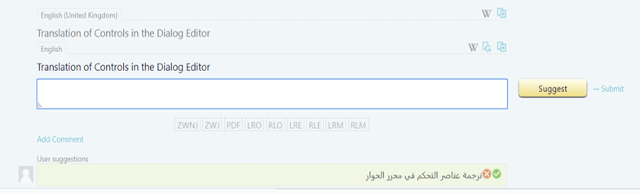

I submit my suggestion, and I can see the accept/reject options for my own suggestions….

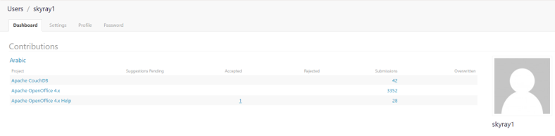
After accepting my own suggestion, it has been marked on the “Accepted” count, on my profile.

