Storm Use Case Scenario

Apache Storm servers primarily as a stream processing engine. It works in the real time and analyzes large amounts of data. As you know, Apache Airavata requires a framework to orchestrate its multiple jobs and tasks. We will get potentially try to get the input somehow in the form of a directed acyclic graph (DAG). In Storm, these DAGs are known as topologies. A Storm cluster runs two types of nodes: master nodes and worker nodes. The master node runs a daemon called Nimbus in the background. This is very similar to Apache Hadoop’s JobTracker. The Nimbus part keeps track of distributing the code to the cluster, assigning tasks to target workers, and check if a worker/job has failed or not. In addition to this master node, the worker nodes run a program called Supervisor. Workers take work from the Nimbus section. The workers take the work given by Nimbus and start/stop accordingly. Thus, this can be classified as a push based approach since Nimbus does the assigning. Very similar to MapReduce/ Hadoop, Storm runs something known as Spouts/Bolts. Analogous to map and reduce, spouts and bolts are the fundamental building blocks of Storm. Spouts act as a “reader” to read data from external and/or internal sources. The collect data to be then converted to a bolt. The bolt aspect of Storm actually conducts the processing. Storm uses Zookeeper in place to keep track of the cluster. The messaging systems between Nimbus and other worker nodes is done through Zookeeper.
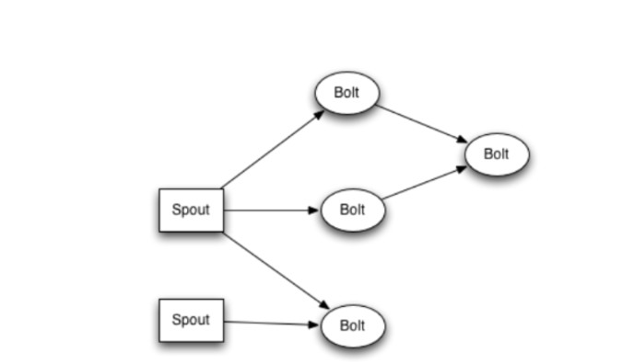
As shown in teh picture above, we can see how bolts/spouts are executed. There can be multiple instances of spouts to receive data stream. Bolts can also be run in parallel where significant overlap occurs. Each circle can be thought of as a graph node where a small/big processing step occurs. After a topology is submitted, the Nimbus consults with the worker nodes via the “Supervisor” to see what bolts to execute. In apache airavata, we can potentially use this idea to orchestrate our jobs/tasks using such bolts/spouts. The spout in the Airavata case could be some type of database such as CouchDB, Cassandra, or MongoDB. This can be the source of the data input for the Storm cluster. After that, the topologies(DAGS) get passed to the cluster and then are handed off to Nimbus. The Nimbus then carries on with the execution and orchestrates the worker nodes. We can potentially use this idea to connect the input/output aspect of the orchestrator requirements. I will try to implement the specifics after we decide what to go with .

