Spark Use Case Scenario

Apache Airavata requires an internal framework for managing incoming work requests. The user API provides inputs on what task needs to be executed in one particular job. This, however, applies to numerous tasks and jobs instead of just one particular case. We have to assume that these tasks are not related to each other. Because of this situation, one cannot use big data query frameworks such as Presto, Hive, or Pig. The input would most likely be stored and/or retrieved as a directed acyclic graph (DAG). Our requirement is to have a framework in place that analyzes this DAG and guides each task execution on the target worker machines. Fault tolerance, low maintenance, and high scalability are all desirable traits in this orchestration process. We analyzed Apache Spark and Storm as potential solutions for the orchestration requirement. Both frameworks meet the criteria outlined for the project. Spark was of particular interest because of its vibrant community and new developments. These two factors can potentially positively impact the development process significantly. An active community can address issues much quicker and provide relevant solutions. This is very convenient considering that this part of the Airavata project should be low maintenance. Spark provides a core engine along with other popularly used libraries in database processing, machine learning, and parallel graph processing. We won’t, however, be using any of these capabilities. Our interest lies solely in the core Spark engine. The Spark architecture will be the underlying technology used for Airavata. Through the Spark Context, it will control the flow of the DAGs and pass them to the task executors. These task executors will potentially be scaled horizontally to provide high scalability. Our aim is to configure Spark with a No-SQL database such as CouchDB/Cassandra and connect it to these task executors. This will allow Spark to read from the database and coordinate which tasks are sent to which task executors.

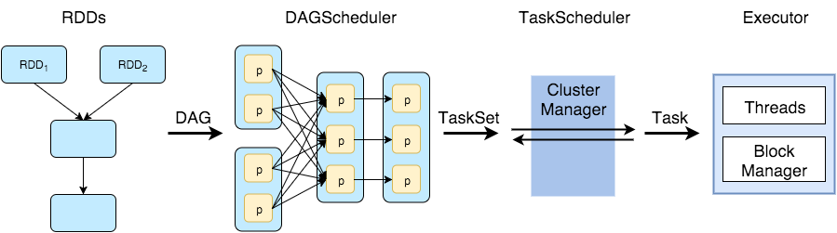

The above diagram shows the Spark architecture in detail. We are not worrying about its underlying implementation. The native DAGScheduler should be easily broken apart and connected to each task executor after reading from the database. It is important to notice that only a small functionality of Spark is used. We will be ignoring other functionalities at this time.

