

**Calle Colon 60, 46004-Valencia-spain.**

**Fax: +34 961125611**

Ref: CAS/2574/OCTOBER/2021

Date: 25/10/2021

Mr. PAUL DAVIS

Email: pauldavisinc@hotmail.com

**Dear Friend**

My names are **Paul Davis** and I work with **CUBLINKS AUDIT SERVICES** España. Actually, I got your contact information from your country’s public records while searching for a last name similar to my late client's a business magnate by name **Kim ,**an accident that occurred along Barcelona-Tarragona high way in Spain, December 2008.

Prior to my explaining further, I must first make an apology for this unsolicited mail to you. I am conscious that this is certainly not a predictable way of approach to foster a relationship of trust but because of the circumstances and urgency surrounding this claim. Before the catastrophe; He deposited One Trunk Box/Diplomatic Personal Treasure, containing the sum of **$8.5M(EIGHT MILLION, FIVE HUNDRED THOUSAND US DOLLARS)** with a Safe Security Company here in Spain because of security and personal reasons he did not disclose the exact content of deposited diplomatic box to the **SAFE HOUSE**. As the attorney to late **Kim,** the security company has mandated me to present a member of his family (heir/inheritor) to make Claims or the vault will be confiscated and taken to the Bureau of Diplomatic Security as unclaimed.

After exhaustive efforts of search for a direct family member to my late client which came to no avail, I was given an ultimatum to look for some relative to come for the claim or have the Vault liquidated and made unserviceable in accordance with existing laws. Against this backdrop, my suggestion to you is that I will like you to stand as the next of kin. I know you may not be anyway related to my late client but having a common surname with him and the modality I have in place I can guarantee that if you follow my instructions (The rule of laws) and capitalizing of some judicial loop holes, the vault will be release to us.

Mind you that this transaction is 100% risk free; there is no atom of risk connected to this business as I have worked out all modalities to complete the operation effectively.   
Once the consignment (vault) is released to you, we shall divide the content in the ratio of 35% for you, 60% for me and 5% will be set aside for all expenses incur during the claim process.

Kindly indicate your responses to this mail either via my private email address. Please be kind to get back to me if you are not willing to collaborate with me so that I can further my search for another partner.

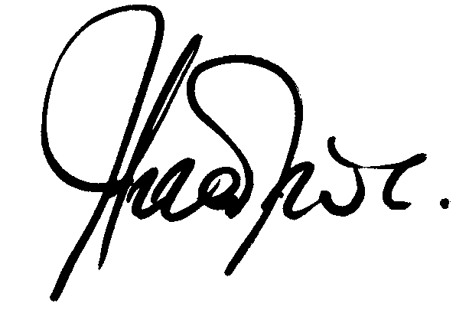**Kindest Regards**

**MR.PAUL DAVIS**

Private Email: pauldavisinc@hotmail.com