Linux

This is the command I execute. I copy the input file to the directory where the executable software resides

./QuateXelero –i yeast -s 10 –r 100

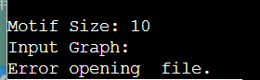

I am using your file, I do not know why this error occurs, I hope to get your help.

Windows

The ones in the red box are my commands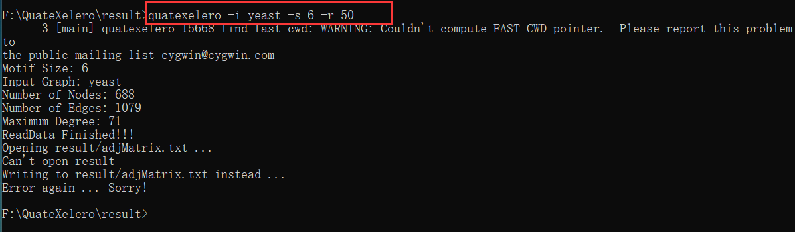

I'll put these files under ‘result’ folder

