The Limitation on 3rd Toolchains
On each build command, the build system:
- Sets the $PATH env variable
build/soong/cmd/path_interposer/main.go
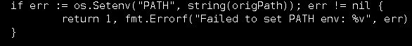

- Checks the Configuration of the build command, if it is not allowed (the Error field in the Configuration is set to true) or is it configured to be logged (the Log field in the Configuration is set to true) an error log will be sent to a unix domain socket.
When the build command is not allowed, not only the error logs are generated, the build stops immediately
The Configuration of the command is determined through the apis in config.go
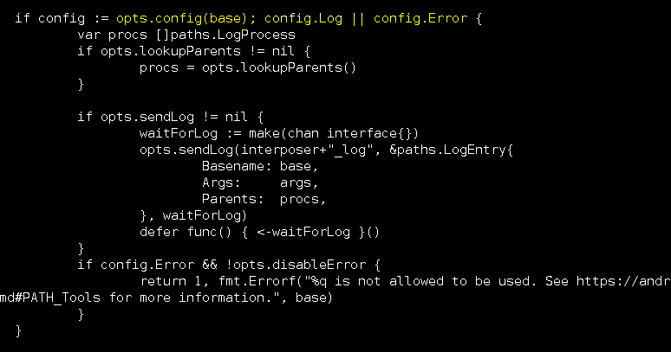

There’s a table which sets up a mapping between the command (as string) and the Configuration of it
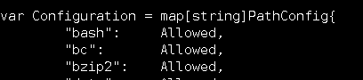
A Configuration consists of fields to indicate the setup of the command
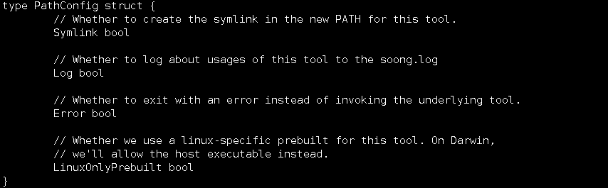
For example, Allowed is setup like this:
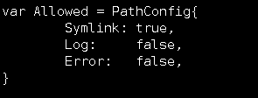
Where the Error field is set to false (of course)
And Forbidden is setup like this:
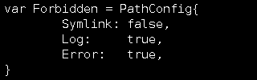
Where the Error field is set to true
Note that if the command is unknown to the mapping, it will be reported as Missing:
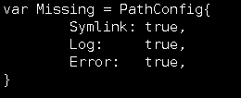
Which is almost equivelent to Forbidden with the exception that a symlink will be created for it, but still results in an error when actually used

- Then the error logs are received through a listener on the same socket
build/soong/ui/build/path.go
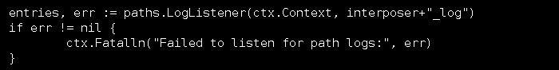

- The listener picks up the log and generates the error messages we see a lot in the attached log
build/soong/ui/build/path.go
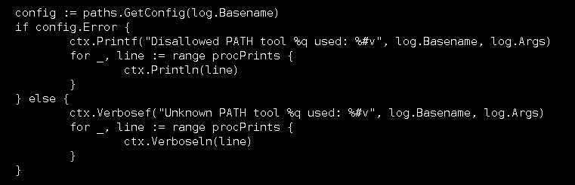

Where the first line shows what tool was used on what file,
16:02:39 Disallowed PATH tool "perl" used: []string{"perl", "/mfs/mtkslt0383/mtk12437/git_tag/apollo/middleware/open/x_include.pl"}
16:02:39 See https://android.googlesource.com/platform/build/+/master/Changes.md#PATH_Tools for more information.

Than the process tree shows how the command is triggered
16:02:39 Process tree:
16:02:39 â†’ make SHELL=/bin/bash -f /mfs/mtkslt0383/mtk12437/git_tag/apollo/middleware/open/all.mak x_inc SUB_COMP= LEVEL_TOP=FALSE
16:02:39 â†’ /bin/bash -c if [ -d /mfs/mtkslt0383/mtk12437/git_tag/apollo/middleware/open/../protect/mtp_mngr/mtp_mngr_common ]; then \ make SHELL=/bin/bash -C /mfs/mtkslt0383/mtk12437/git_tag/apollo/middleware/open/../protect/mtp_mngr/mtp_mngr_common x_inc ENTER_OPT_SUB_COMP=FALSE LEVEL_TOP=FALSE ; \ elif [ -d /mfs/mtkslt0383/mtk12437/git_tag/apollo/middleware/open/../limit_open/mtp_mngr/mtp_mngr_common ]; then \ make SHELL=/bin/bash -C /mfs/mtkslt0383/mtk12437/git_tag/apollo/middleware/open/../limit_open/mtp_mngr/mtp_mngr_common x_inc ENTER_OPT_SUB_COMP=TRUE ; \ else \ make SHELL=/bin/bash -C mtp_mngr x_inc ENTER_OPT_SUB_COMP=FALSE LEVEL_TOP=FALSE ; \ fi
16:02:39 â†’ make SHELL=/bin/bash -C mtp_mngr x_inc ENTER_OPT_SUB_COMP=FALSE LEVEL_TOP=FALSE
16:02:39 â†’ make SHELL=/bin/bash -C mtp_mngr x_inc ENTER_OPT_SUB_COMP=FALSE LEVEL_TOP=FALSE
16:02:39 â†’ make SHELL=/bin/bash -f /mfs/mtkslt0383/mtk12437/git_tag/apollo/middleware/open/all.mak x_inc SUB_COMP= LEVEL_TOP=FALSE
16:02:39 â†’ make SHELL=/bin/bash -f /mfs/mtkslt0383/mtk12437/git_tag/apollo/middleware/open/all.mak x_inc SUB_COMP= LEVEL_TOP=FALSE
16:02:39 â†’ /bin/bash -c perl /mfs/mtkslt0383/mtk12437/git_tag/apollo/middleware/open/x_include.pl < x_mtp_req.h > /mfs/mtkslt0383/mtk12437/git_tag/android/q-base/out/mediatek_linux/output/mediatek/balto/rel/inc/x_inc/common_inc/x_mtp_req.h
16:02:39 â†’ perl /mfs/mtkslt0383/mtk12437/git_tag/apollo/middleware/open/x_include.pl

